What I did not show in that post was how to use the model for making predictions. This, I will do here. But predictions alone are boring, so I’m adding explanations for the predictions using the lime package.

Neither of them applies LIME to image classification models, though. And with the new(ish) release from March of ime package, lime is now not only on CRAN but it natively supports Keras and image classification models.

Here, I am following to use Imagenet (VGG16) to make and explain predictions of fruit images and then I am extending the analysis to and compare it with the pretrained net.

**Loading libraries and models**

library(keras) # for working with neural nets

library(lime) # for explaining models

library(magick) # for preprocessing images

library(ggplot2) # for additional plotting

* Loading the pretrained Imagenet model

model <- application_vgg16(weights = "imagenet", include_top = TRUE)

model

## Model

## ___________________________________________________________________________

## Layer (type) Output Shape Param #

## ===========================================================================

## input_1 (InputLayer) (None, 224, 224, 3) 0

## ___________________________________________________________________________

## block1_conv1 (Conv2D) (None, 224, 224, 64) 1792

## ___________________________________________________________________________

## block1_conv2 (Conv2D) (None, 224, 224, 64) 36928

## ___________________________________________________________________________

## block1_pool (MaxPooling2D) (None, 112, 112, 64) 0

## ___________________________________________________________________________

## block2_conv1 (Conv2D) (None, 112, 112, 128) 73856

## ___________________________________________________________________________

## block2_conv2 (Conv2D) (None, 112, 112, 128) 147584

## ___________________________________________________________________________

## block2_pool (MaxPooling2D) (None, 56, 56, 128) 0

## ___________________________________________________________________________

## block3_conv1 (Conv2D) (None, 56, 56, 256) 295168

## ___________________________________________________________________________

## block3_conv2 (Conv2D) (None, 56, 56, 256) 590080

## ___________________________________________________________________________

## block3_conv3 (Conv2D) (None, 56, 56, 256) 590080

## ___________________________________________________________________________

## block3_pool (MaxPooling2D) (None, 28, 28, 256) 0

## ___________________________________________________________________________

## block4_conv1 (Conv2D) (None, 28, 28, 512) 1180160

## ___________________________________________________________________________

## block4_conv2 (Conv2D) (None, 28, 28, 512) 2359808

## ___________________________________________________________________________

## block4_conv3 (Conv2D) (None, 28, 28, 512) 2359808

## ___________________________________________________________________________

## block4_pool (MaxPooling2D) (None, 14, 14, 512) 0

## ___________________________________________________________________________

## block5_conv1 (Conv2D) (None, 14, 14, 512) 2359808

## ___________________________________________________________________________

## block5_conv2 (Conv2D) (None, 14, 14, 512) 2359808

## ___________________________________________________________________________

## block5_conv3 (Conv2D) (None, 14, 14, 512) 2359808

## ___________________________________________________________________________

## block5_pool (MaxPooling2D) (None, 7, 7, 512) 0

## ___________________________________________________________________________

## flatten (Flatten) (None, 25088) 0

## ___________________________________________________________________________

## fc1 (Dense) (None, 4096) 102764544

## ___________________________________________________________________________

## fc2 (Dense) (None, 4096) 16781312

## ___________________________________________________________________________

## predictions (Dense) (None, 1000) 4097000

## ===========================================================================

## Total params: 138,357,544

## Trainable params: 138,357,544

## Non-trainable params: 0

## ___________________________________________________________________________

Define Model

**Define model**

Next, we define the keras model.

# number of training samples

train_samples <- train_image_array_gen$n

# number of validation samples

valid_samples <- valid_image_array_gen$n

# define batch size and number of epochs

batch_size <- 32

epochs <- 10

The model I am using here is a very simple sequential convolutional neural net with the following hidden layers: 2 convolutional layers, one pooling layer and one dense layer.

# initialise model

model <- keras_model_sequential()

# add layers

model %>%

layer_conv_2d(filter = 32, kernel_size = c(3,3), padding = "same", input_shape = c(img_width, img_height, channels)) %>%

layer_activation("relu") %>%

# Second hidden layer

layer_conv_2d(filter = 16, kernel_size = c(3,3), padding = "same") %>%

layer_activation_leaky_relu(0.5) %>%

layer_batch_normalization() %>%

# Use max pooling

layer_max_pooling_2d(pool_size = c(2,2)) %>%

layer_dropout(0.25) %>%

# Flatten max filtered output into feature vector

# and feed into dense layer

layer_flatten() %>%

layer_dense(100) %>%

layer_activation("relu") %>%

layer_dropout(0.5) %>%

# Outputs from dense layer are projected onto output layer

layer_dense(output_n) %>%

layer_activation("softmax")

# compile

model %>% compile(

loss = "categorical_crossentropy",

optimizer = optimizer_rmsprop(lr = 0.0001, decay = 1e-6),

metrics = "accuracy"

)

Fit the model; because I used image_data_generator() and flow_images_from_directory() I am now also using the fit_generator() to run the training.

# fit

hist <- model %>% fit_generator(

# training data

train_image_array_gen,

# epochs

steps_per_epoch = as.integer(train_samples / batch_size),

epochs = epochs,

# validation data

validation_data = valid_image_array_gen,

validation_steps = as.integer(valid_samples / batch_size),

# print progress

verbose = 2,

callbacks = list(

# save best model after every epoch

callback_model_checkpoint("/Users/shiringlander/Documents/Github/DL_AI/Tutti_Frutti/fruits-360/keras/fruits_checkpoints.h5", save_best_only = TRUE),

# only needed for visualising with TensorBoard

callback_tensorboard(log_dir = "/Users/shiringlander/Documents/Github/DL_AI/Tutti_Frutti/fruits-360/keras/logs")

)

)

In RStudio we are seeing the output as an interactive plot in the “Viewer” pane but we can also plot it:

plot(hist)

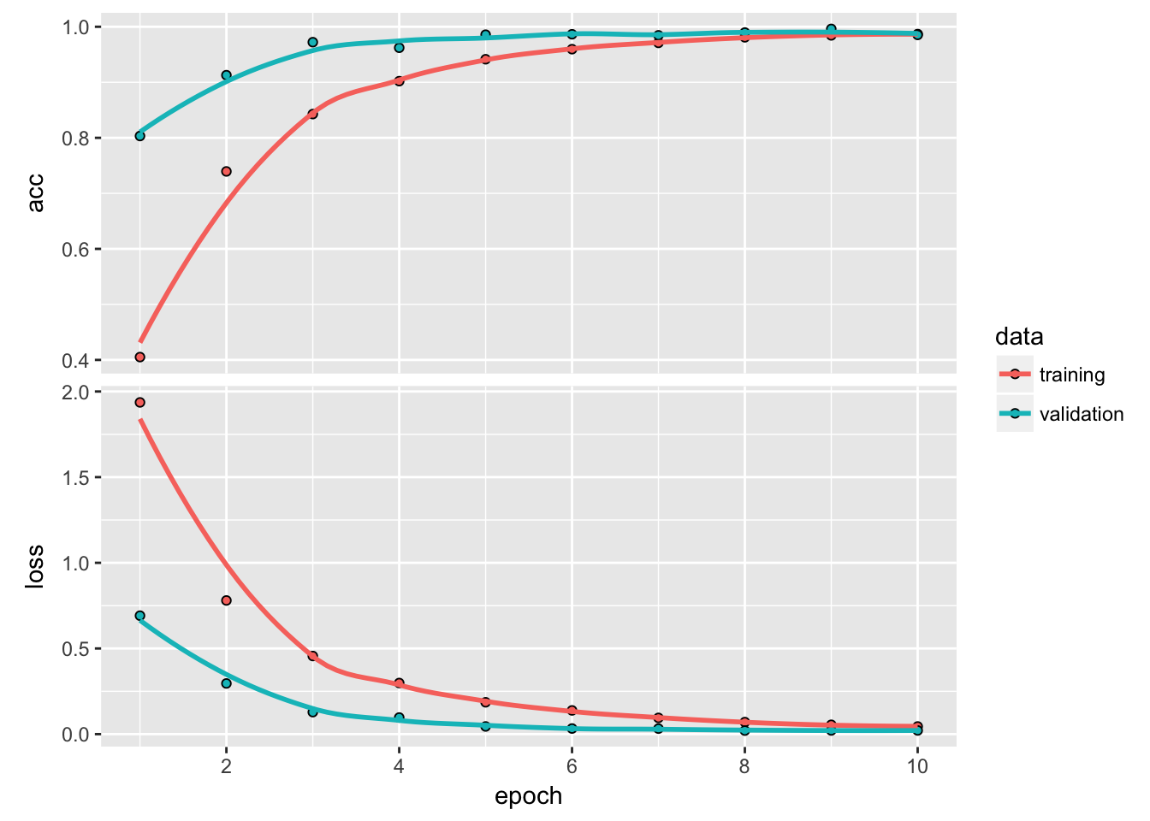

As we can see, the model is quite accurate on the validation data. However, we need to keep in mind that our images are very uniform, they all have the same white background and show the fruits centered and without anything else in the images. Thus, our model will not work with images that don’t look similar as the ones we trained on (that’s also why we can achieve such good results with such a small neural net).

model2 <- load_model_hdf5(filepath = "/Users/shiringlander/Documents/Github/DL_AI/Tutti_Frutti/fruits-360/keras/fruits_checkpoints.h5")

model2

## Model

## ___________________________________________________________________________

## Layer (type) Output Shape Param #

## ===========================================================================

## conv2d_1 (Conv2D) (None, 20, 20, 32) 896

## ___________________________________________________________________________

## activation_1 (Activation) (None, 20, 20, 32) 0

## ___________________________________________________________________________

## conv2d_2 (Conv2D) (None, 20, 20, 16) 4624

## ___________________________________________________________________________

## leaky_re_lu_1 (LeakyReLU) (None, 20, 20, 16) 0

## ___________________________________________________________________________

## batch_normalization_1 (BatchNorm (None, 20, 20, 16) 64

## ___________________________________________________________________________

## max_pooling2d_1 (MaxPooling2D) (None, 10, 10, 16) 0

## ___________________________________________________________________________

## dropout_1 (Dropout) (None, 10, 10, 16) 0

## ___________________________________________________________________________

## flatten_1 (Flatten) (None, 1600) 0

## ___________________________________________________________________________

## dense_1 (Dense) (None, 100) 160100

## ___________________________________________________________________________

## activation_2 (Activation) (None, 100) 0

## ___________________________________________________________________________

## dropout_2 (Dropout) (None, 100) 0

## ___________________________________________________________________________

## dense_2 (Dense) (None, 16) 1616

## ___________________________________________________________________________

## activation_3 (Activation) (None, 16) 0

## ===========================================================================

## Total params: 167,300

## Trainable params: 167,268

## Non-trainable params: 32

## ___________________________________________________________________________

**Load and prepare images**

Here, I am loading and preprocessing two images of fruits (and yes, I am cheating a bit because I am choosing images where I expect my model to work as they are similar to the training images…).

* Banana

test_image_files_path <- "/Users/shiringlander/Documents/Github/DL_AI/Tutti_Frutti/fruits-360/Test"

img <- image_read('<https://upload.wikimedia.org/wikipedia/commons/thumb/8/8a/Banana-Single.jpg/272px-Banana-Single.jpg>')

img_path <- file.path(test_image_files_path, "Banana", 'banana.jpg')

image_write(img, img_path)

#plot(as.raster(img))

* Clementine

img2 <- image_read('<https://cdn.pixabay.com/photo/2010/12/13/09/51/clementine-1792_1280.jpg>')

img_path2 <- file.path(test_image_files_path, "Clementine", 'clementine.jpg')

image_write(img2, img_path2)

#plot(as.raster(img2))

**Superpixels**

The segmentation of an image into superpixels are an important step in generating explanations for image models. It is both important that the segmentation is correct and follows meaningful patterns in the picture, but also that the size/number of superpixels are appropriate. If the important features in the image are chopped into too many segments the permutations will probably damage the picture beyond recognition in almost all cases leading to a poor or failing explanation model. As the size of the object of interest is varying it is impossible to set up hard rules for the number of superpixels to segment into - the larger the object is relative to the size of the image, the fewer superpixels should be generated. Using plot_superpixels it is possible to evaluate the superpixel parameters before starting the time consuming explanation function. (help(plot_superpixels))

plot_superpixels(img_path, n_superpixels = 35, weight = 10)

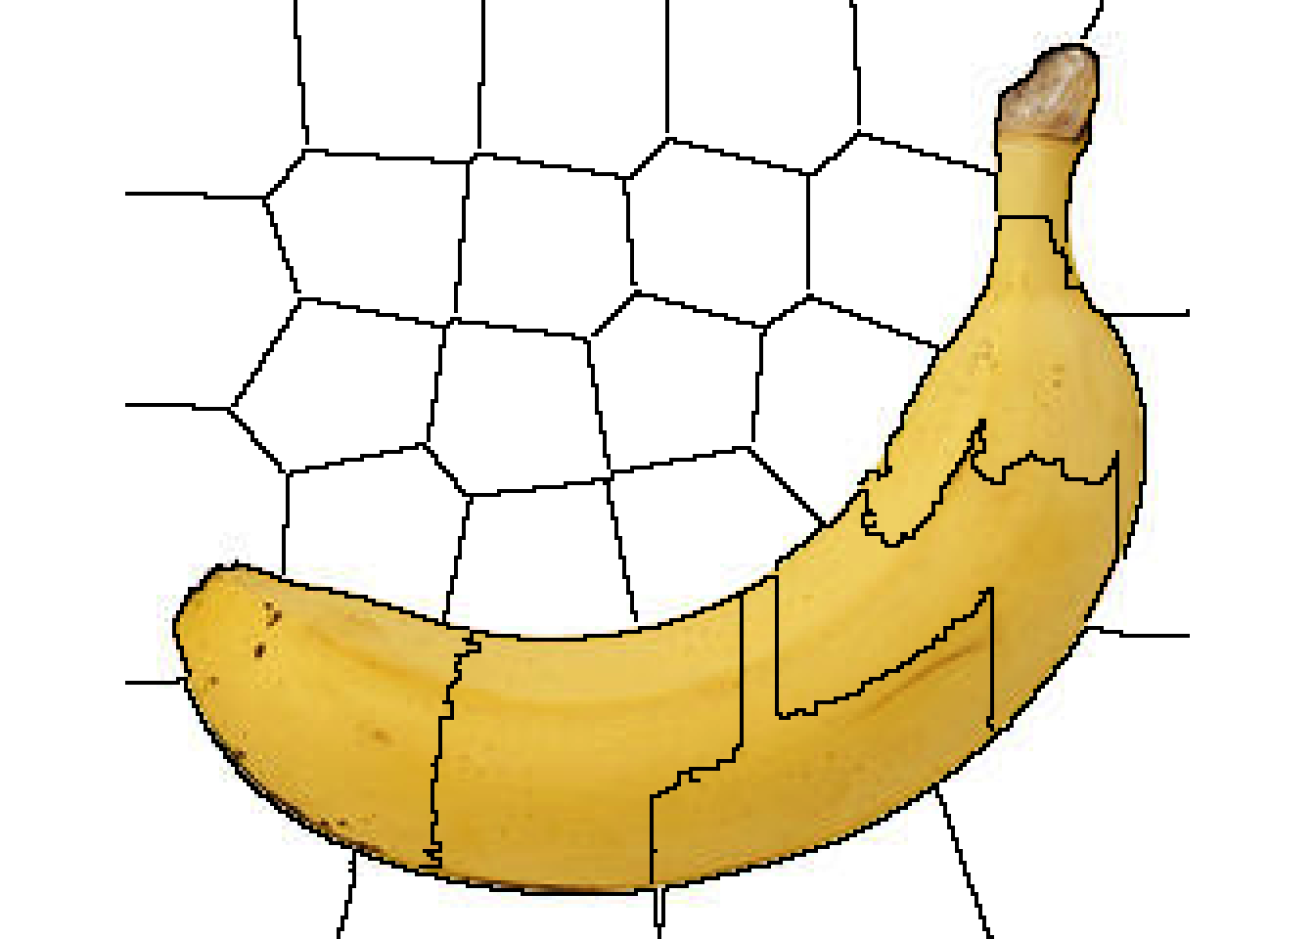

plot_superpixels(img_path2, n_superpixels = 50, weight = 20)

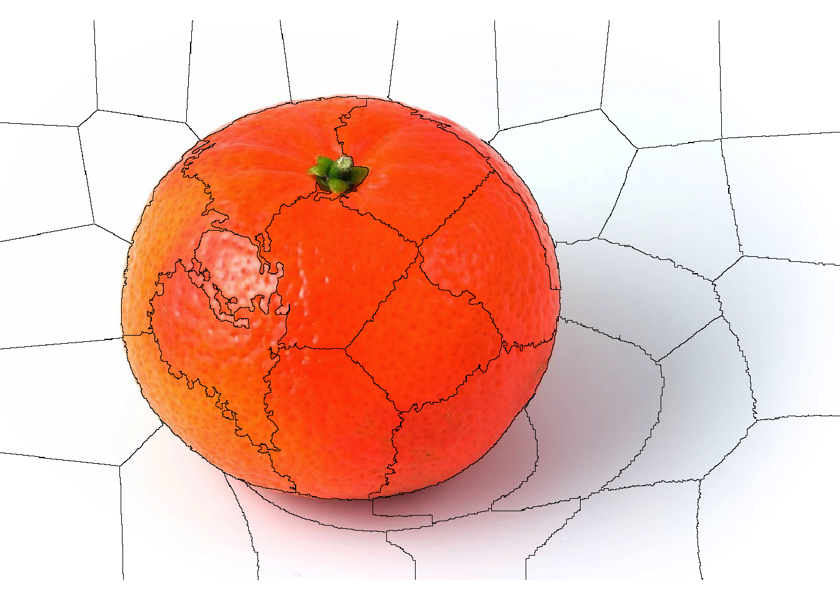

From the superpixel plots we can see that the clementine image has a higher resolution than the banana image.

**Prepare images for Imagenet**

image_prep <- function(x) {

arrays <- lapply(x, function(path) {

img <- image_load(path, target_size = c(224,224))

x <- image_to_array(img)

x <- array_reshape(x, c(1, dim(x)))

x <- imagenet_preprocess_input(x)

})

do.call(abind::abind, c(arrays, list(along = 1)))

}

* test predictions

res <- predict(model, image_prep(c(img_path, img_path2)))

imagenet_decode_predictions(res)

## [[1]]

## class_name class_description score

## 1 n07753592 banana 0.9929747581

## 2 n03532672 hook 0.0013420776

## 3 n07747607 orange 0.0010816186

## 4 n07749582 lemon 0.0010625814

## 5 n07716906 spaghetti_squash 0.0009176208

##

## [[2]]

## class_name class_description score

## 1 n07747607 orange 0.78233224

## 2 n07753592 banana 0.04653566

## 3 n07749582 lemon 0.03868873

## 4 n03134739 croquet_ball 0.03350329

## 5 n07745940 strawberry 0.01862431

* load labels and train explainer

model_labels <- readRDS(system.file('extdata', 'imagenet_labels.rds', package = 'lime'))

explainer <- lime(c(img_path, img_path2), as_classifier(model, model_labels), image_prep)

Training the explainer (explain() function) can take pretty long. It will be much faster with the smaller images in my own model but with the bigger Imagenet it takes a few minutes to run.

explanation <- explain(c(img_path, img_path2), explainer,

n_labels = 2, n_features = 35,

n_superpixels = 35, weight = 10,

background = "white")

* plot_image_explanation() only supports showing one case at a time

plot_image_explanation(explanation)

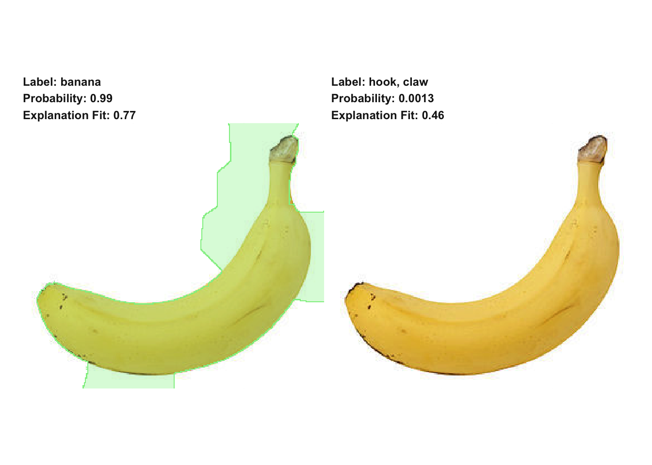

clementine <- explanation[explanation$case == "clementine.jpg",]

plot_image_explanation(clementine)

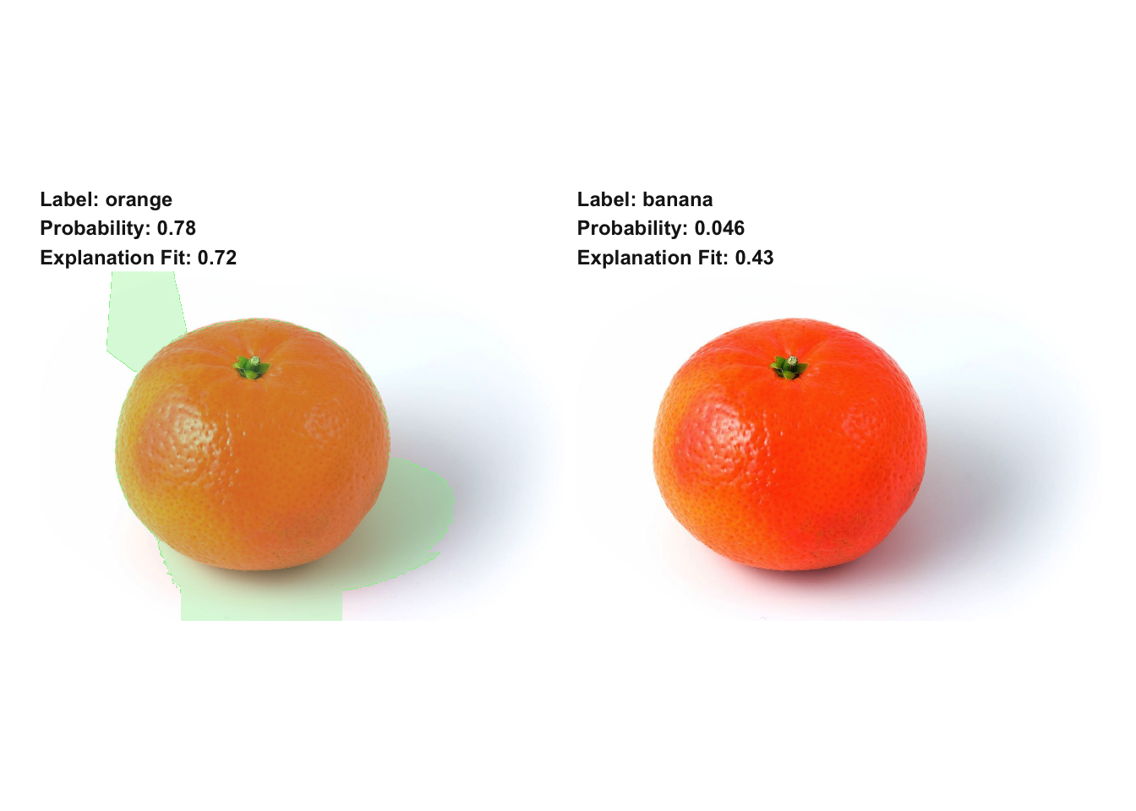

**Prepare images for my own model**

* test predictions (analogous to training and validation images)

test_datagen <- image_data_generator(rescale = 1/255)

test_generator <- flow_images_from_directory(

test_image_files_path,

test_datagen,

target_size = c(20, 20),

class_mode = 'categorical')

predictions <- as.data.frame(predict_generator(model2, test_generator, steps = 1))

load("/Users/shiringlander/Documents/Github/DL_AI/Tutti_Frutti/fruits-360/fruits_classes_indices.RData")

fruits_classes_indices_df <- data.frame(indices = unlist(fruits_classes_indices))

fruits_classes_indices_df <- fruits_classes_indices_df[order(fruits_classes_indices_df$indices), , drop = FALSE]

colnames(predictions) <- rownames(fruits_classes_indices_df)

t(round(predictions, digits = 2))

## [,1] [,2]

## Kiwi 0 0

## Banana 0 1

## Apricot 0 0

## Avocado 0 0

## Cocos 0 0

## Clementine 1 0

## Mandarine 0 0

## Orange 0 0

## Limes 0 0

## Lemon 0 0

## Peach 0 0

## Plum 0 0

## Raspberry 0 0

## Strawberry 0 0

## Pineapple 0 0

## Pomegranate 0 0

for (i in 1:nrow(predictions)) {

cat(i, ":")

print(unlist(which.max(predictions[i, ])))

}

## 1 :Clementine

## 6

## 2 :Banana

## 2

This seems to be incompatible with lime, though (or if someone knows how it works, please let me know) - so I prepared the images similarly to the Imagenet images.

image_prep2 <- function(x) {

arrays <- lapply(x, function(path) {

img <- image_load(path, target_size = c(20, 20))

x <- image_to_array(img)

x <- reticulate::array_reshape(x, c(1, dim(x)))

x <- x / 255

})

do.call(abind::abind, c(arrays, list(along = 1)))

}

* prepare labels

fruits_classes_indices_l <- rownames(fruits_classes_indices_df)

names(fruits_classes_indices_l) <- unlist(fruits_classes_indices)

fruits_classes_indices_l

## 9 10 8 2 11

## "Kiwi" "Banana" "Apricot" "Avocado" "Cocos"

## 3 13 14 7 6

## "Clementine" "Mandarine" "Orange" "Limes" "Lemon"

## 1 5 0 4 15

## "Peach" "Plum" "Raspberry" "Strawberry" "Pineapple"

## 12

## "Pomegranate"

* train explainer

explainer2 <- lime(c(img_path, img_path2), as_classifier(model2, fruits_classes_indices_l), image_prep2)

explanation2 <- explain(c(img_path, img_path2), explainer2,

n_labels = 1, n_features = 20,

n_superpixels = 35, weight = 10,

background = "white")

* plot feature weights to find a good threshold for plotting block (see below)

explanation2 %>%

ggplot(aes(x = feature_weight)) +

facet_wrap(~ case, scales = "free") +

geom_density()

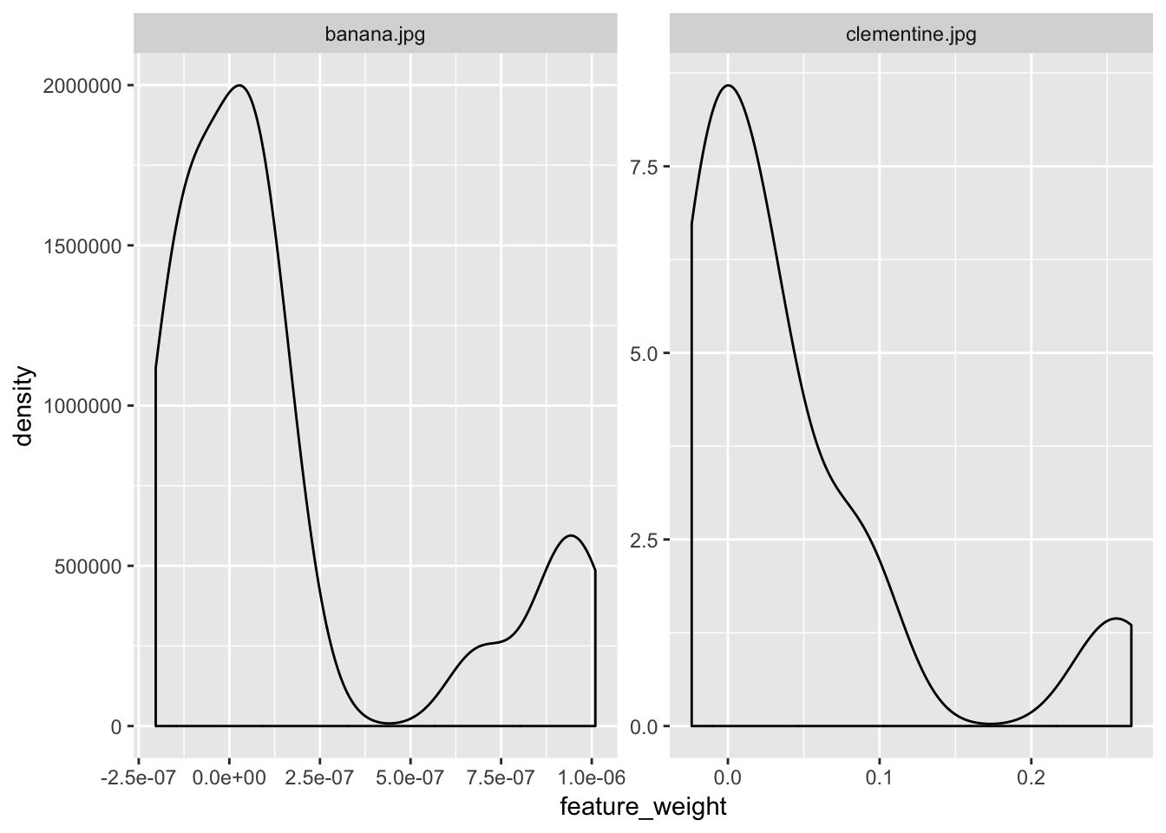

* plot predictions

plot_image_explanation(explanation2, display = 'block', threshold = 5e-07)

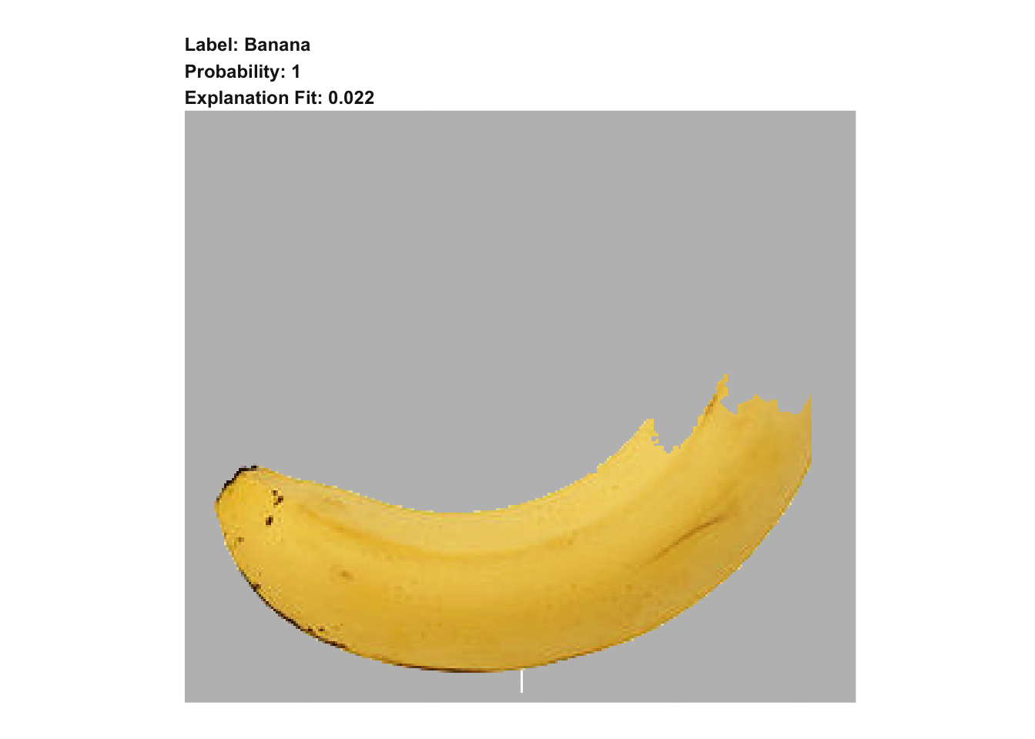

clementine2 <- explanation2[explanation2$case == "clementine.jpg",]

plot_image_explanation(clementine2, display = 'block', threshold = 0.16)

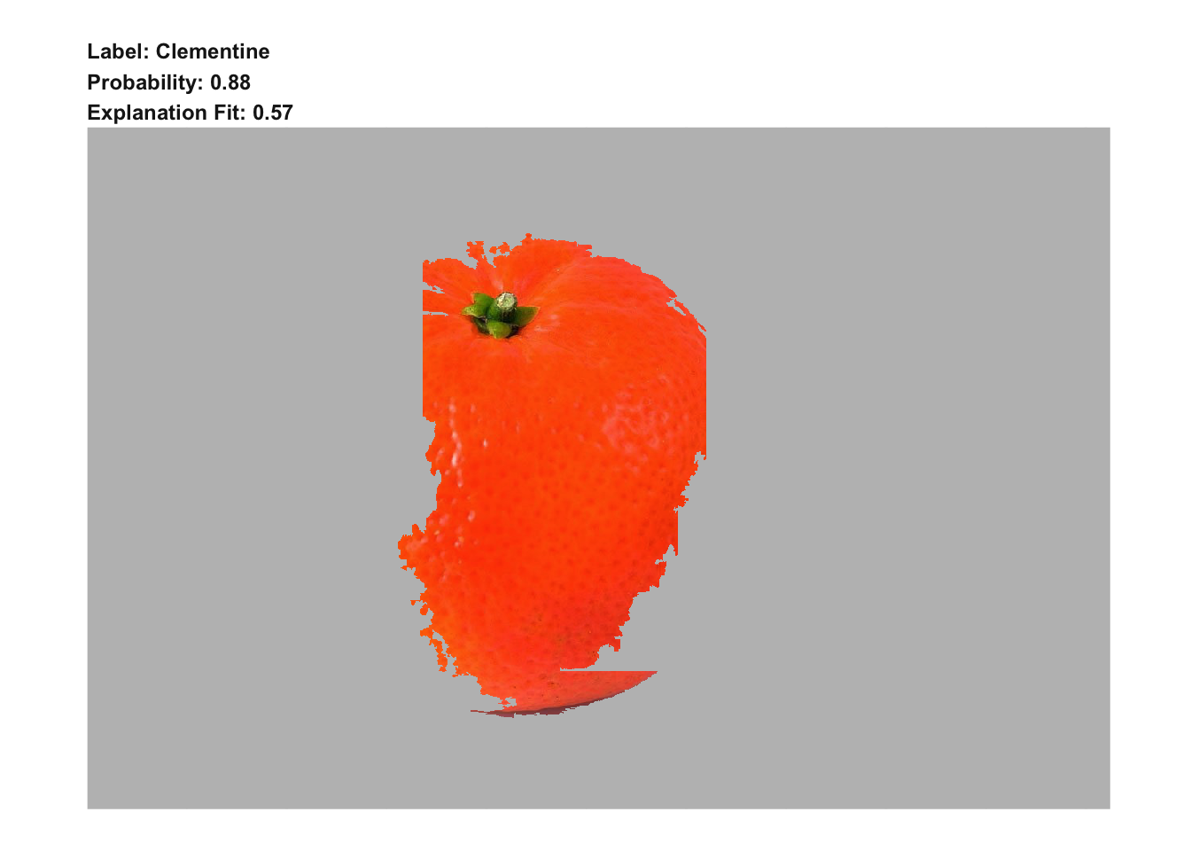

sessionInfo()

## R version 3.5.1 (2018-07-02)

## Platform: x86_64-apple-darwin15.6.0 (64-bit)

## Running under: macOS High Sierra 10.13.6

##

## Matrix products: default

## BLAS: /Library/Frameworks/R.framework/Versions/3.5/Resources/lib/libRblas.0.dylib

## LAPACK: /Library/Frameworks/R.framework/Versions/3.5/Resources/lib/libRlapack.dylib

##

## locale:

## [1] de_DE.UTF-8/de_DE.UTF-8/de_DE.UTF-8/C/de_DE.UTF-8/de_DE.UTF-8

##

## attached base packages:

## [1] stats graphics grDevices utils datasets methods base

##

## other attached packages:

## [1] ggplot2_3.0.0 magick_1.9 lime_0.4.0 keras_2.1.6

##

## loaded via a namespace (and not attached):

## [1] stringdist_0.9.5.1 reticulate_1.8.0.9003 tidyselect_0.2.4

## [4] xfun_0.3 purrr_0.2.5 lattice_0.20-35

## [7] colorspace_1.3-2 htmltools_0.3.6 yaml_2.1.19

## [10] base64enc_0.1-3 rlang_0.2.1 pillar_1.2.3

## [13] later_0.7.3 withr_2.1.2 glue_1.2.0

## [16] bindrcpp_0.2.2 foreach_1.4.4 plyr_1.8.4

## [19] bindr_0.1.1 tensorflow_1.8 stringr_1.3.1

## [22] munsell_0.5.0 blogdown_0.6 gtable_0.2.0

## [25] htmlwidgets_1.2 codetools_0.2-15 evaluate_0.10.1

## [28] labeling_0.3 knitr_1.20 httpuv_1.4.4.2

## [31] tfruns_1.3 curl_3.2 parallel_3.5.1

## [34] Rcpp_0.12.17 xtable_1.8-2 scales_0.5.0

## [37] backports_1.1.2 promises_1.0.1 jsonlite_1.5

## [40] abind_1.4-5 mime_0.5 digest_0.6.15

## [43] stringi_1.2.3 bookdown_0.7 dplyr_0.7.6

## [46] shiny_1.1.0 grid_3.5.1 rprojroot_1.3-2

## [49] tools_3.5.1 magrittr_1.5 shinythemes_1.1.1

## [52] lazyeval_0.2.1 glmnet_2.0-16 tibble_1.4.2

## [55] whisker_0.3-2 pkgconfig_2.0.1 zeallot_0.1.0

## [58] Matrix_1.2-14 gower_0.1.2 assertthat_0.2.0

## [61] rmarkdown_1.10 iterators_1.0.9 R6_2.2.2

## [64] compiler_3.5.1